September Week 2 Report - Ito’s Lemma and the Black-Scholes Equation
Project: AI/ML-Augmented Black-Scholes Framework for Option Pricing and Market-Risk Analysis
Plan reference: Section 16 (16.5 - 16.19), tasks 1 - 13
Primary text: Carol Alexander, Market Risk Analysis Volume I: Quantitative Methods in Finance, sections I.3.7 and I.5
Submitted by: Sanskar
Contents
1. Objective and scope
2. Task 1 - from ordinary Taylor expansion to Ito’s lemma
3. Task 2 - dynamics of the derivative
4. Task 3 - numerical illustration of Ito’s lemma
5. Task 4 - second Ito experiment: the GBM solution derived
6. Tasks 5 and 6 - delta hedging and the elimination of dW
7. The central question - where did the physical drift go?
8. Task 7 - the no-arbitrage argument and the Black-Scholes PDE
9. Interpretation of the PDE, and verification that the formula satisfies it
10. Task 8 - the terminal condition
11. Tasks 9 to 11 - pricing implementation and put-call parity
12. Task 12 - parameter sensitivity
13. Task 13 - connecting the derivation back to Week 1
14. Conclusions

1. Objective and scope
Week 1 established the stochastic process. Week 2 turns that process into a pricing equation. The progression is
Quadratic Variation -> Ito’s Lemma -> Derivative Dynamics -> Delta Hedging -> Elimination of dW -> No-Arbitrage -> Black-Scholes PDE -> European Call and Put Pricing
The derivation is the principal task; the computation exists to verify it, not to replace it. Accordingly every numerical section below states what claim is being tested and what result would falsify it.
All thirteen tasks of section 16 were completed.
Task | Content | Plan ref. | Report section
1 | From ordinary Taylor expansion to Ito’s lemma | 16.5 | 2
2 | Dynamics of the derivative | 16.6 | 3
3 | Numerical illustration of Ito’s lemma | 16.7 | 4
4 | Second Ito experiment, f(S) = ln S | 16.8 | 5
5 | Construct the delta-hedged portfolio | 16.9 | 6
6 | Choose the hedge ratio, show dW cancels | 16.10 | 6, 7
7 | Apply the no-arbitrage argument | 16.12 | 8
8 | Introduce the terminal payoff | 16.14 | 10
9 | Implement the European call formula | 16.15 | 11
10 | Implement the European put formula | 16.16 | 11
11 | Put-call parity | 16.17 | 11
12 | Understand the Black-Scholes inputs | 16.18 | 12
13 | Connect the derivation back to Week 1 | 16.19 | 13

2. Task 1 - from ordinary Taylor expansion to Ito’s lemma
Begin with a second-order Taylor expansion of $V=V(S,t)$:
$$dV=V_{t} dt+V_{S} dS+1/2V_{SS}(dS)^{2}+V_{St} dS dt+1/2V_{tt}(dt)^{2}+⋯$$
In ordinary calculus every term beyond first order is discarded, because along a differentiable path $(dS)^{2}$ is of order $(dt)^{2}$ and therefore negligible.
For Brownian motion that reasoning fails. With $dS=μS dt+σS dW$,
$$(dS)^{2}=μ^{2}S^{2}(dt)^{2}+2μσS^{2} dt dW+σ^{2}S^{2}(dW)^{2}$$
and the three stochastic multiplication rules are
$$(dt)^{2}=0, dt dW=0, (dW)^{2}=dt$$
The first two vanish faster than $dt$. The third does not. This is precisely the quadratic-variation result measured in Week 1, where $∑(ΔW)^{2}→T$ while $∑|ΔW|→∞$. Hence
$$(dS)^{2}=σ^{2}S^{2} dt$$
which is of order $dt$, the same order as the first-order terms, and so cannot be dropped.
This single fact is the whole of Ito calculus.

Numerical verification
The identity $(dS)^{2}=σ^{2}S^{2} dt$ was checked directly on a simulated path by comparing the realised $∑(ΔS)^{2}$ against $σ^{2}∑S^{2}Δt$, with $S_{0}=100$, $μ=0.10$, $σ=0.30$, $T=1$.
Steps $n$ | $∑(ΔS)^{2}$ | $σ^{2}∑S^{2}Δt$ | ratio
100 | 1,015.16 | 963.44 | 1.0537
1,000 | 985.28 | 989.39 | 0.9958
10,000 | 1,058.79 | 1,061.79 | 0.9972
100,000 | 1,037.63 | 1,038.05 | 0.9996
1,000,000 | 1,012.41 | 1,014.94 | 0.9975
The ratio converges to 1. The relation is not an approximation introduced for convenience; it is a measurable property of the path.

3. Task 2 - dynamics of the derivative
Substituting $(dS)^{2}=σ^{2}S^{2}dt$ into the Taylor expansion:
$$dV=V_{t} dt+V_{S} dS+1/2σ^{2}S^{2}V_{SS} dt$$
Now substituting $dS=μS dt+σS dW$ and collecting terms:
$$dV=\underset{\text{deterministic}}{\underset{⏟}{\left[V_{t}+μSV_{S}+1/2σ^{2}S^{2}V_{SS}\right]dt}}+\underset{\text{stochastic}}{\underset{⏟}{σSV_{S} dW}}$$
Two observations before proceeding, both of which matter later:
- $μ$ appears in the drift of $dV$. It has not yet disappeared. Anyone who claims at this stage that Black-Scholes “does not depend on the expected return” has skipped a step.
- The stochastic part carries the factor $V_{S}$. The derivative and the underlying are driven by the same Brownian motion $dW$. That shared driver is what makes exact cancellation possible in Task 6.

4. Task 3 - numerical illustration of Ito’s lemma
Take $f(W)=W^{2}$. Ito’s lemma gives
$$d(W^{2})=2W dW+dt$$
whereas ordinary calculus would give only $2W dW$.
The discrete identity is exact, which makes this a clean test:
WT2=i​Wi+12−Wi2=i​2WiΔWi+i​(ΔWi)2
So the error committed by ordinary calculus is exactly $∑(ΔW)^{2}$, which converges to $T$. The Week 1 quadratic-variation result reappears here as the extra term in Ito’s lemma.
Steps $n$ | $W_{T}^{2}$ (truth) | $∫2W dW$ only | $∫2W dW+∑(ΔW)^{2}$ | error of ordinary
10 | 3.57103601 | 1.81722147 | 3.57103601 | 1.75381454
100 | 0.41199378 | -0.53159003 | 0.41199378 | 0.94358381
1,000 | 4.99363075 | 3.99917482 | 4.99363075 | 0.99445593
10,000 | 1.09625264 | 0.09590311 | 1.09625264 | 1.00034954
100,000 | 1.54418757 | 0.53812866 | 1.54418757 | 1.00605891
1,000,000 | 0.41297148 | -0.58825348 | 0.41297148 | 1.00122497
Two things to read from this table.
The Ito column reproduces $W_{T}^{2}$ to machine precision - maximum absolute difference 1.23e-14 across all six resolutions. The correction is not approximately right; it is exactly right.
The ordinary column is wrong by 1.0012, that is, by $T=1$. The error does not shrink as the partition is refined. It converges to a fixed, non-zero amount. That amount is the $∫dt$ term.
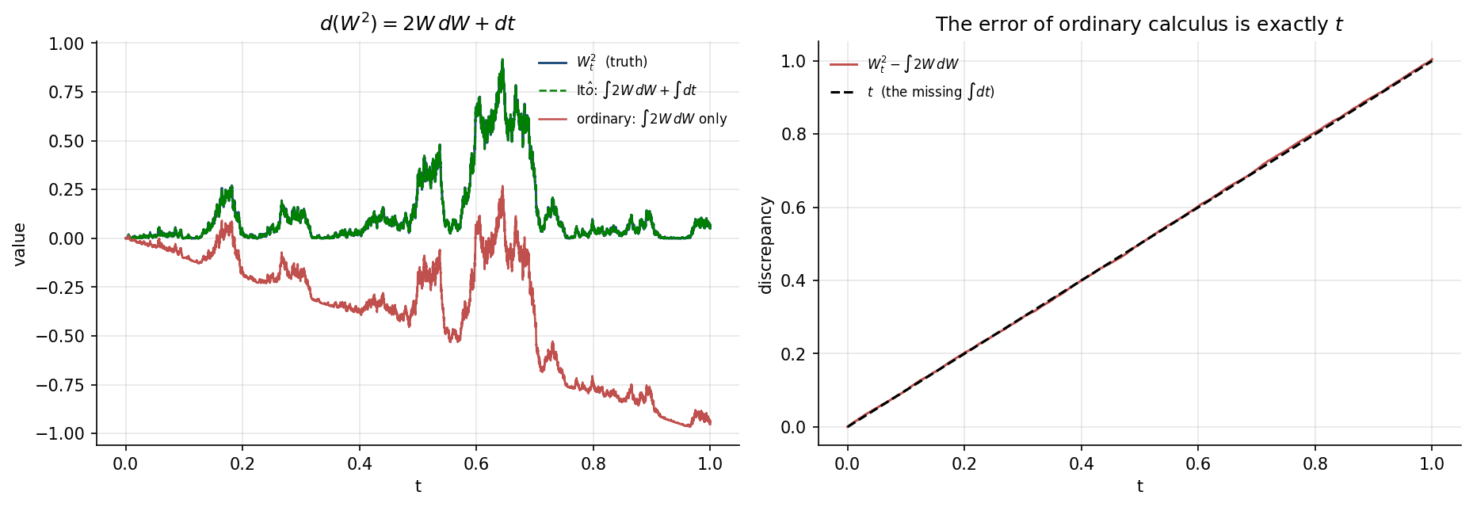
Figure 1. Left: the running values of $W_{t}^{2}$, of $∫2W dW$ alone, and of the Ito expression. The Ito curve lies exactly on the truth; the ordinary curve drifts steadily below it. Right: the discrepancy $W_{t}^{2}−∫2W dW$ plotted against the line $y=t$. The two coincide, confirming that the missing quantity is precisely $\int_{0}^{t}{d}s=t$.

5. Task 4 - second Ito experiment: the GBM solution derived
Apply Ito’s lemma to $f(S)=\text{ln}S$, for which $f′=1/S$ and $f″=−1/S^{2}$:
$$d(\text{ln}S)=\frac{1}{S}dS−\frac{1}{2S^{2}}(dS)^{2}$$
Substituting $dS=μS dt+σS dW$ and $(dS)^{2}=σ^{2}S^{2}dt$:
$$d(\text{ln}S)=\left(μ−1/2σ^{2}\right)dt+σ dW$$
Ordinary calculus would give only $\frac{1}{S}dS=μ dt+σ dW$, missing the $−1/2σ^{2}$ drift correction entirely.
Verified numerically with $S_{0}=100$, $μ=0.12$, $σ=0.35$, $T=1$, so that the theoretical correction is $−σ^{2}T/2=−0.061250$:
Steps $n$ | $\text{ln}(S_{T}/S_{0})$ (truth) | $∑ΔS/S$ (ordinary) | difference
100 | -0.30238652 | -0.24175551 | -0.06063101
1,000 | 0.24484975 | 0.30592185 | -0.06107210
10,000 | -0.18708422 | -0.12595137 | -0.06113285
100,000 | 0.05545694 | 0.11667243 | -0.06121549
1,000,000 | -0.13291126 | -0.07152651 | -0.06138475
Observed -0.061385 against a theoretical -0.061250. Integrating the correct expression:
$$S_{T}=S_{0}\text{exp}\left[\left(μ−1/2σ^{2}\right)T+σW_{T}\right]$$
This is the GBM solution used computationally throughout Week 1, now derived rather than assumed. Item 8 of the progress table asked for exactly this.

6. Tasks 5 and 6 - delta hedging and the elimination of dW
Hold one derivative and short $Δ$ units of the underlying:
$$Π=V−ΔS, dΠ=dV−Δ dS$$
Substituting the expressions for $dV$ and $dS$:
$$dΠ=\left[V_{t}+μSV_{S}+1/2σ^{2}S^{2}V_{SS}−ΔμS\right]dt+\left[σSV_{S}−ΔσS\right]dW$$
The $dW$ coefficient vanishes if and only if
$$\boxed{Δ=V_{S}}$$
and with that choice the terms $μSV_{S}$ and $ΔμS$ become identical and cancel at the same moment:
$$dΠ=\left[V_{t}+1/2σ^{2}S^{2}V_{SS}\right]dt$$
The portfolio is now locally riskless: over an infinitesimal interval its value changes deterministically.

7. The central question - where did the physical drift go?
This is the conceptual core of the week, so it is worth stating precisely rather than merely observing that $μ$ is absent from the final equation.
Mathematically. $μ$ enters $dV$ only through the term $V_{S} dS$, and it enters $Δ dS$ through the same channel. Setting $Δ=V_{S}$ makes those two contributions identical, so they cancel - simultaneously with the $dW$ terms. Removing the risk and removing the drift are not two separate steps. They are one operation.
Financially. The hedge neutralises all first-order exposure to $S$. Whatever the underlying is expected to do on average is already fully offset by the position in the underlying itself, so the expected return of the stock cannot influence the value of the hedged package. Two investors who disagree completely about $μ$ must still agree on the option price, provided they agree on $σ$.
What survives is $1/2σ^{2}S^{2}V_{SS}$, pure convexity, which depends on the variance of the underlying and not on its mean.

Numerical demonstration
A short at-the-money call was delta-hedged 252 times over one year across 20,000 paths, with $S_{0}=K=100$, $r=5\%$, $σ=25\%$, and the same random shocks reused for each drift. The Black-Scholes premium received was 12.335999.
$μ$ | hedged mean | hedged s.d. | unhedged mean | unhedged s.d. | risk removed
0.00 | -0.002433 | 0.548601 | 3.027019 | 17.075131 | 96.8%
0.15 | -0.005785 | 0.529479 | -7.686913 | 24.722506 | 97.9%
0.30 | -0.020597 | 0.473165 | -23.528006 | 32.254710 | 98.5%
The comparison that matters is the spread across $μ$:
Quantity | Spread across $μ∈\{0.00,0.15,0.30\}$
Unhedged mean P&L | 26.555024
Hedged mean P&L | 0.018164
Hedged standard deviation | 0.075436
The unhedged position’s expected profit moves by more than 26 units as the drift changes - as it must, since a higher drift makes a short call far more likely to finish in the money. The hedged position moves by 0.018, roughly a factor of 1,500 smaller.
That invariance is the numerical content of the statement that $μ$ disappears from the Black-Scholes PDE.
The residual hedged dispersion is not a defect in the derivation. It is discrete-rebalancing error: the derivation assumes continuous hedging, whereas here $Δ$ is updated only 252 times. It shrinks as the rebalancing frequency increases, and it is the same effect that will reappear in Week 4 as the gap between binomial and analytical prices.
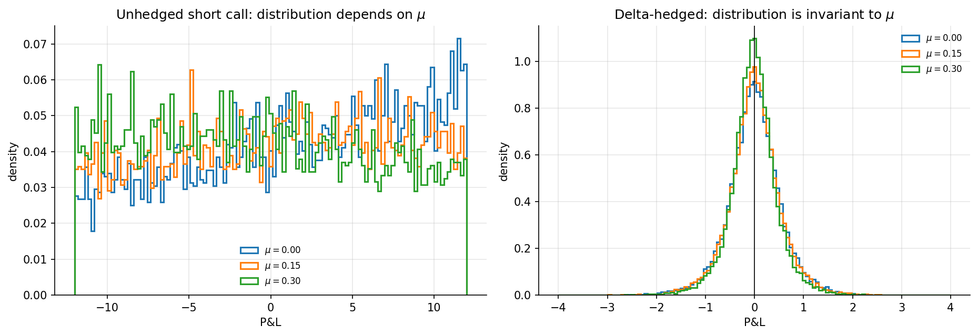
Figure 2. Left: the unhedged short-call P&L distribution shifts substantially with $μ$. Right: the delta-hedged distributions for the three drifts lie almost on top of one another, centred at zero.

8. Task 7 - the no-arbitrage argument and the Black-Scholes PDE
A locally riskless portfolio must earn the risk-free rate. If it earned more, one could borrow at $r$, buy the portfolio, and collect a certain profit with no capital and no risk; if less, the reverse trade would do the same. Hence
$$dΠ=rΠ dt$$
Substituting $Π=V−SV_{S}$ and the expression for $dΠ$ from Section 6:
$$\left[V_{t}+1/2σ^{2}S^{2}V_{SS}\right]dt=r\left(V−SV_{S}\right)dt$$
Rearranging gives the Black-Scholes partial differential equation:
$$\boxed{V_{t}+1/2σ^{2}S^{2}V_{SS}+rSV_{S}−rV=0}$$
Note that $r$ has taken the place of $μ$ in the first-order term. The physical drift is gone; the risk-free rate stands where it stood.

9. Interpretation of the PDE, and verification that the formula satisfies it
Each term should be interpreted rather than memorised.
Term | Meaning
$V_{t}$ | time effect (theta): value change from the passage of time alone
$1/2σ^{2}S^{2}V_{SS}$ | curvature-volatility effect (gamma): the only place volatility enters
$rSV_{S}$ | underlying-price sensitivity under risk-neutral growth
$−rV$ | discounting and financing effect

Verification
The strongest check available this week is to substitute the closed-form price back into the PDE. The derivatives $V_{t}$, $V_{S}$ and $V_{SS}$ were computed by central differences on the analytical formula, noting that because the formula is stated in time-to-maturity $τ$, $V_{t}=−∂V/∂τ$.
At $τ=1$ year, $K=100$, $r=5\%$, $σ=25\%$:
$S$ | $V$ | $V_{t}$ | $V_{S}$ | $V_{SS}$ | PDE residual
60 | 0.240150 | -0.800249 | 0.042871 | 0.006077 | 1.5e-07
80 | 3.141523 | -4.379498 | 0.285162 | 0.016980 | -8.6e-07
90 | 6.869814 | -6.200918 | 0.461585 | 0.017649 | 2.1e-06
100 | 12.335999 | -7.250495 | 0.627409 | 0.015137 | -5.9e-07
110 | 19.305092 | -7.489333 | 0.759981 | 0.011305 | 1.2e-05
120 | 27.406343 | -7.187144 | 0.854124 | 0.007628 | 6.4e-06
150 | 55.278058 | -5.667036 | 0.974224 | 0.001599 | -6.4e-06
Across all 35 tested $(S,τ)$ points:
Quantity | Value
Maximum absolute residual | 3.343e-05
Mean absolute residual | 5.602e-06
Typical option value | 16.228
The residual sits at the level of finite-difference truncation error, roughly nine orders of magnitude below the prices themselves. The closed-form formula satisfies the PDE that was derived above, which confirms the derivation and the implementation simultaneously.

10. Task 8 - the terminal condition
The PDE constrains how value evolves; it does not say what the value is. It admits infinitely many solutions. What selects the option price is the terminal payoff:
$$V(S,T)=\text{max}(S−K,0) \text{(call)}, V(S,T)=\text{max}(K−S,0) \text{(put)}$$
Verified numerically by letting $τ→0$ with $K=100$:
$τ$ | $S=80$ | $S=95$ | $S=100$ | $S=105$ | $S=120$
1e-02 | 0.000000 | 0.018989 | 1.022274 | 5.073443 | 20.049988
1e-04 | 0.000000 | 0.000000 | 0.099985 | 5.000500 | 20.000500
1e-06 | 0.000000 | 0.000000 | 0.009976 | 5.000005 | 20.000005
0 | 0.000000 | 0.000000 | 0.000000 | 5.000000 | 20.000000
intrinsic | 0.000000 | 0.000000 | 0.000000 | 5.000000 | 20.000000
The prices converge to the intrinsic value. The at-the-money column converges most slowly, which is the numerical signature of the payoff kink at $S=K$.
The Black-Scholes problem is therefore not the PDE alone, but the PDE together with its terminal condition.

11. Tasks 9 to 11 - pricing implementation and put-call parity
The European call and put formulas were implemented in black_scholes.py:
$$C=SN(d_{1})−Ke^{−rT}N(d_{2}), P=Ke^{−rT}N(−d_{2})−SN(−d_{1})$$
$$d_{1}=\frac{\text{ln}(S/K)+\left(r+1/2σ^{2}\right)T}{σ\sqrt{T}}, d_{2}=d_{1}−σ\sqrt{T}$$
The limits $T→0$ and $σ→0$ make $d_{1}$ and $d_{2}$ singular and are handled explicitly, returning the discounted intrinsic value, which is the correct limit.
Representative prices with $K=100$, $r=5\%$, $σ=25\%$:
$T$ | $S$ | $m=\text{ln}(S/K)$ | call | put | $C−P$ | $S−Ke^{−rT}$
0.25 | 80 | -0.2231 | 0.210352 | 18.968132 | -18.757780 | -18.757780
0.25 | 100 | 0.0000 | 5.598400 | 4.356180 | 1.242220 | 1.242220
0.25 | 120 | 0.1823 | 21.590210 | 0.347990 | 21.242220 | 21.242220
1.00 | 80 | -0.2231 | 3.141523 | 18.264466 | -15.122942 | -15.122942
1.00 | 100 | 0.0000 | 12.335999 | 7.458941 | 4.877058 | 4.877058
1.00 | 120 | 0.1823 | 27.406343 | 2.529285 | 24.877058 | 24.877058
2.00 | 100 | 0.0000 | 18.647076 | 9.130818 | 9.516258 | 9.516258
The last two columns agree in every row, which is put-call parity holding pointwise.

Put-call parity over a grid
Defining the parity error
$$ε_{PCP}=C−P−S+Ke^{−rT}$$
and evaluating over a full grid of $S$, $K$, $T$, $r$ and $σ$:
Quantity | Value
Grid points | 13,500
Maximum $|ε|$ | 4.263e-14
Mean $|ε|$ | 4.667e-15
99.9th percentile $|ε|$ | 2.842e-14
Typical option value | 12.336
Parity holds to machine precision.
What this test does and does not establish. Put-call parity is model-free: it follows from a static no-arbitrage argument that holds in any arbitrage-free model, not from the Black-Scholes dynamics. A non-zero $ε$ would therefore indicate an implementation bug, not a modelling limitation. This tests the code, not the model.
An independent self-test on 20,000 randomly drawn parameter sets additionally confirmed non-negativity, the upper bounds $C≤S$ and $P≤Ke^{−rT}$, the lower bounds $C≥\text{max}(S−Ke^{−rT},0)$ and $P≥\text{max}(Ke^{−rT}−S,0)$, and the $T→0$ and $σ→0$ limits. All passed.

12. Task 12 - parameter sensitivity
The option price was varied with respect to $S$, $K$, $σ$, $T$ and $r$, one variable at a time.
Check | Result
$∂C/∂S>0$ everywhere | passed
$∂C/∂S$ range | 1.19e-62 to 0.99901
$∂C/∂K<0$ everywhere | passed
Vega $=S\sqrt{T}φ(d_{1})>0$ (analytic) | passed
$C(σ)$ non-decreasing numerically | passed
Minimum analytic vega on tested range | 3.10e-23
Call increasing in $T$ (at the money) | passed
Deep in-the-money put non-monotone in $T$ | confirmed
$∂C/∂r>0$ | passed
$∂P/∂r<0$ | passed
A note on the vega check. The first version of this test failed, and the cause is worth recording. At $σ=0.001$ with $S=80$, $K=100$, the argument $d_{1}≈−173$, so $φ(d_{1})$ is of order ${10}^{−6500}$ and underflows to exactly zero in double precision. Vega remains strictly positive mathematically; it is simply not representable. Similarly, in the flat deep in-the-money region consecutive prices are bitwise identical, so the numerical slope is exactly zero rather than negative. The test was therefore restated: positivity is checked on the analytic form where it is resolvable, and the numerical curve is checked for non-decrease. This is a limitation of the floating-point format, not of the model or the implementation.
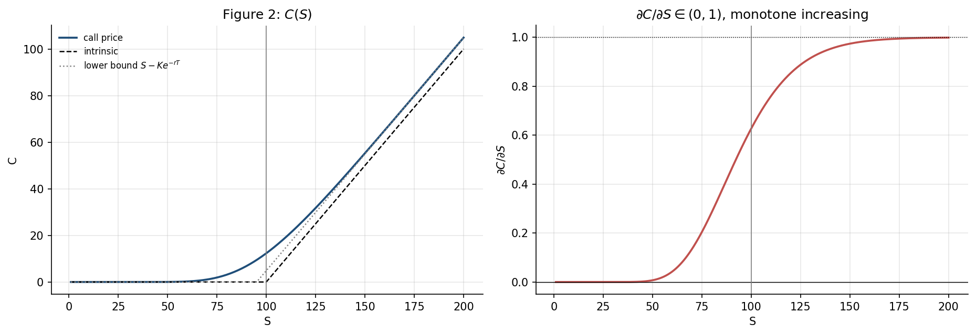
Figure 3. Left: $C(S)$ against the intrinsic value and the lower bound $S−Ke^{−rT}$. The price lies above both everywhere, and approaches the lower bound for large $S$. Right: $∂C/∂S$, which is the delta, rising monotonically from 0 to 1.
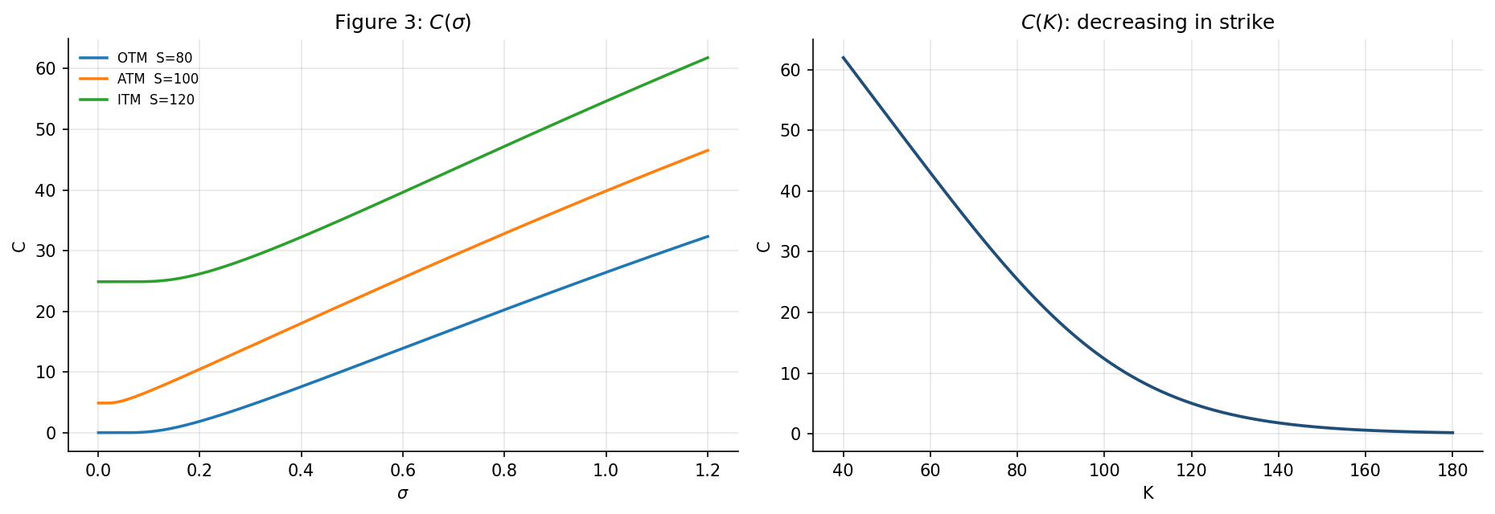
Figure 4. Left: $C(σ)$ at three moneyness levels. All three curves are increasing. Right: $C(K)$, decreasing in the strike.
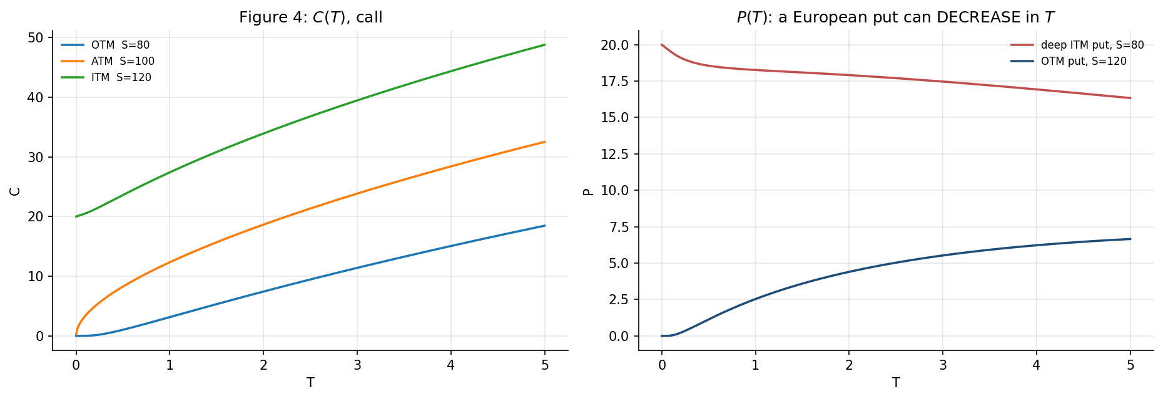
Figure 5. Left: $C(T)$ for out-of-the-money, at-the-money and in-the-money calls, all increasing. Right: $P(T)$, showing that a deep in-the-money European put can decrease in maturity.
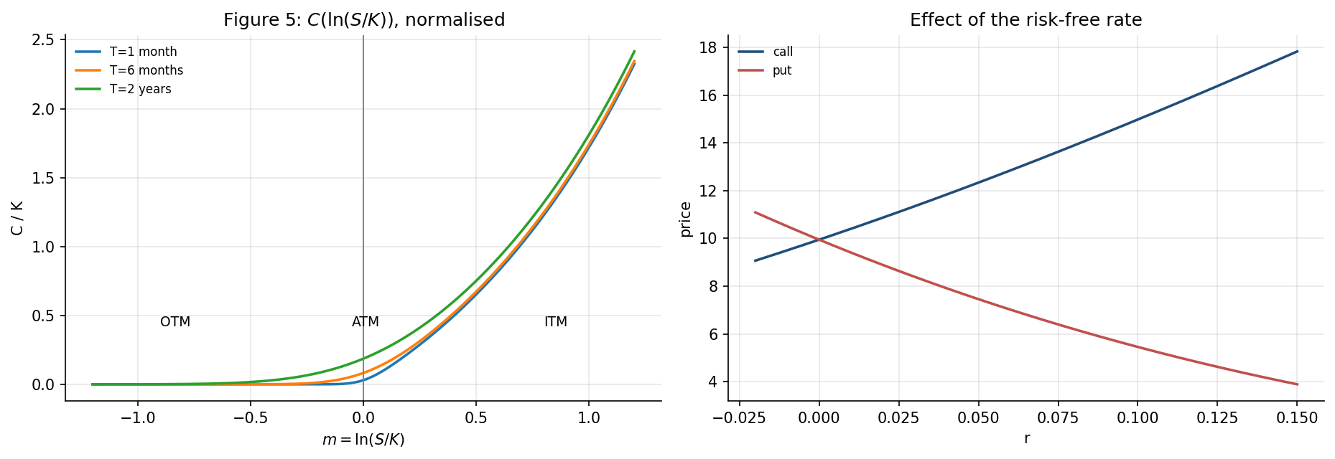
Figure 6. Left: normalised call value $C/K$ against log moneyness $m=\text{ln}(S/K)$ for three maturities, with the OTM, ATM and ITM regions marked. Right: the effect of the risk-free rate on calls and puts, in opposite directions.

What these results mean
$∂C/∂S∈(0,1)$. This is the delta. A call never gains more than the stock itself, and never loses value when the stock rises. The upper bound of 1 is why a delta hedge requires at most one share per option.
$∂C/∂K<0$. A higher strike is a worse exercise price for the holder.
$∂C/∂σ>0$ at every moneyness. The holder has limited downside and unlimited upside, so more dispersion is unambiguously better. That this holds everywhere is why volatility, rather than price, is the quantity actually traded in option markets, and it is what makes implied volatility a well-defined inversion in Week 3.
The call increases in $T$, but a deep in-the-money European put can decrease in $T$. This is not an artefact. For such a put the dominant term is the discounted strike $Ke^{−rT}$ received at maturity, and a longer maturity delays that receipt. This is precisely why American puts can be worth strictly more than European ones: early exercise recovers the lost discounting. It will matter when American exercise appears later in the project.
$∂C/∂r>0$ and $∂P/∂r<0$. A higher rate lowers the present value of the strike, which helps the party who pays it and hurts the party who receives it.

13. Task 13 - connecting the derivation back to Week 1
The derivation above is mathematically exact given its assumptions. Each of those assumptions was measured against market data in Week 1.
Classical model assumption | Empirical observation (Week 1)
Continuous diffusion; no jumps | 15 days beyond 4 sigma and 10 beyond 5 sigma in 2,458 observations
Constant volatility $σ$ | Volatility clustering: $|$return$|$ autocorrelation 0.31 at lag 1, still 0.09 at lag 30
Gaussian log-return innovations | Skewness -1.41, excess kurtosis 20.41, Jarque-Bera $p=0.000$
Independent increments | Return magnitudes show persistent positive dependence
Lognormal asset-price dynamics | Useful benchmark, but an incomplete description of market behaviour
Continuous, costless rebalancing | Not yet tested; discrete-hedging error is visible in Section 7 above
The purpose is not to reject Black-Scholes. The derivation is correct. What this table records is exactly which assumptions are being made, and how each is contradicted by data already measured.
That is what makes the model a benchmark rather than a belief, and it defines the specific gaps the later machine-learning stage is asked to close.

14. Conclusions
- All thirteen tasks of section 16 were completed, together with the derivation from quadratic variation through to the analytical pricing formula.
- The necessity of Ito’s lemma was demonstrated, not asserted. For $f(W)=W^{2}$ the Ito expression reproduces $W_{T}^{2}$ to 1.23e-14, while ordinary calculus is wrong by 1.0012, that is, by exactly $T$, and this error does not shrink with refinement.
- The GBM solution used computationally in Week 1 was derived. Applying Ito’s lemma to $f(S)=\text{ln}S$ gives the $−1/2σ^{2}$ correction, confirmed numerically as -0.061385 against a theoretical -0.061250.
- Delta hedging with $Δ=V_{S}$ removes the $dW$ term and the drift simultaneously, because both enter through $dS$. Numerically, hedging removed 97 to 98 per cent of the dispersion, and the hedged mean P&L varied by only 0.018 across $μ∈\{0,0.15,0.30\}$ against 26.56 for the unhedged position.
- The Black-Scholes PDE was derived from the no-arbitrage condition $dΠ=rΠ dt$, and the closed-form price was verified to satisfy it with a maximum residual of 3.34e-05 against prices of order 16.
- The terminal condition is a necessary part of the problem, verified by convergence of the price to the intrinsic value as $τ→0$.
- Put-call parity holds to 4.26e-14 over 13,500 grid points, together with all bound and limit checks on 20,000 random parameter sets.
- All parameter sensitivities behave as theory requires, including the non-obvious case of a deep in-the-money European put decreasing in maturity.
Position going into Week 3. The classical benchmark is now derived, implemented and independently verified. Week 3 differentiates it to obtain the Greeks, and inverts it to obtain implied volatility - at which point the constant-volatility assumption recorded in Section 13 becomes directly observable as the volatility smile.

